Chapter 1 Lesson 8: Make Direct Selections Pages 1_54 to 1_61

Using the Direct Selection Tool
Adding Anchor Points
Turning Objects into Guides
Working with the Stacking Order
Make Guides and Direct Selections
Add Anchor Points
Use the Draw Behind Drawing Mode
Create a Simple Special Effect Utilizing a Direct Selection

MORE INFO COLLAPSE ALL

What You'll Do

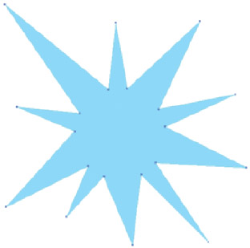
View PDF

In this lesson, you will use the Direct Selection tool and a combination of menu commands, such as Add Anchor Points and Paste in Front, to convert existing shapes into new designs.

Using the Direct Selection Tool
The Direct Selection tool selects individual anchor points or single paths of an object. Using [Shift], you can select multiple anchor points or multiple paths. You can also select multiple points or paths by dragging a direct selection marquee. The tool also selects individual objects within a group, which can be useful for modifying just one object in a complex group. Figure 67 demonstrates the Direct Selection tool selecting one piece of a grouped object.
Clicking the center of an object with the Direct Selection tool selects the entire object. Clicking the edge selects the path segment only; the anchor points on the object all appear white, which means they are not selected. A white anchor point is not selected.
The Direct Selection tool gives you the power to distort simple objects such as squares and circles into unique shapes. Don't underestimate its significance. While the Selection tool is no more than a means to an end for selecting and moving objects, the Direct Selection tool is in itself a drawing tool. You will use it over and over again to modify and perfect your artwork.

Adding Anchor Points
As you distort basic shapes with the Direct Selection tool, you will often find that to create more complex shapes, you will need additional anchor points.
The Add Anchor Points command creates new anchor points without distorting the object. To add anchor points to an object,

Back to TopP. 1_54

click the Object menu, point to Path, then click Add Anchor Points. The new points are automatically positioned exactly between the original anchor points. You can create as many additional points as you wish to use.

Turning Objects into Guides
Guides are one of Illustrator's many features that help you work with precision. Any object you create can be turned into a guide. With the object selected, click the View menu, point to Guides, then click Make Guides. Guides can be locked or unlocked in the same location. It is a good idea to work with locked guides so that they don't interfere with your

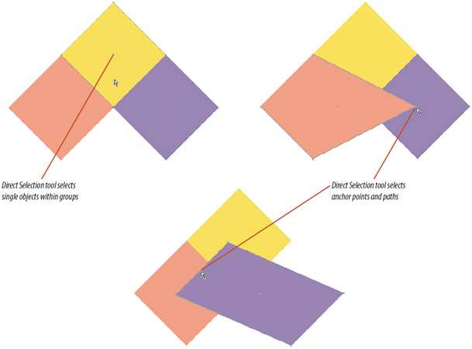
Figure 67 Using the Direct Selection tool View PDF

Back to TopP. 1_55

artwork. Unlock guides only when you want to select them or delete them.
When an object is turned into a guide, it loses its attributes, such as its fill, stroke, and stroke weight. However, Illustrator remembers the original attributes for each guide. To transform a guide back to its original object, first unlock, then select the guide. Click the View menu, point to Guides, then click Release Guides.

Working with the Stacking Order
The stacking order refers to the order of how objects are arranged in front and behind other objects on the artboard. Every time you create an object, it is created in front of the existing objects. (Note that this discussion does not include any role of layers and the Layers panel.) You can manipulate the stacking order with the Arrange commands on the Object menu. See Table 3 below for descriptions of each Arrange command.
You can also use the Draw Behind drawing mode to create an object behind a selected object or at the bottom of the stacking order.
TABLE 3: ARRANGE COMMANDS
Command | Result | quick key (Win) | quick key (Mac)
© Cengage Learning 2013
Bring Forward | Brings a selected object forward one position in the stacking order | [Ctrl][right bracket] | [right bracket]
Bring to Front | Brings a selected object to the very front of the stacking order—in front of all other objects | [Shift][Ctrl] [right bracket] | [Shift]  [right bracket]
Send Backward | Sends a selected object backward one position | [Ctrl][left bracket] | [left bracket]
Send to Back | Sends a selected object to the very back of the stacking order—behind all the other objects | [Shift][Ctrl] [left bracket] | [Shift]  [left bracket]

TABLE 3: ARRANGE COMMANDS © Cengage Learning 2013 View PDF

Back to TopP. 1_56

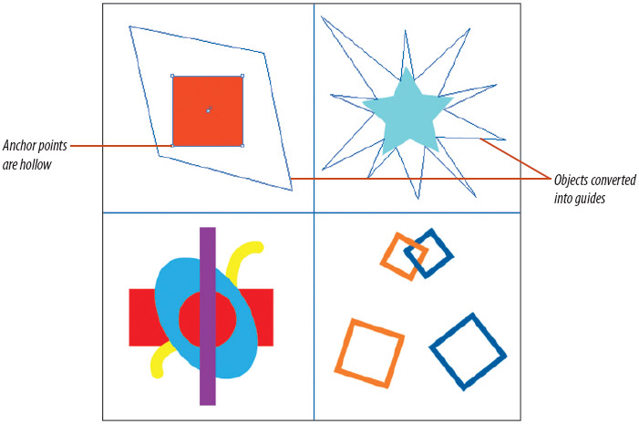
Figure 68 Red square selected with the Direct Selection tool View PDF

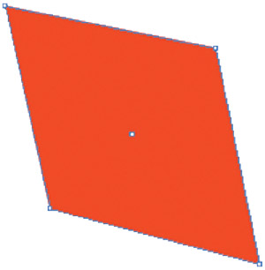
Figure 69 Red square distorted View PDF

Make Guides and Direct Selections
1. Open AI 1-4.ai, then save it as Direct Selections.
2. Click View on the Menu bar, then deactivate the Smart Guides feature.
3. Select the green polygon with the Selection Tool
.
4. Click View on the Menu bar, point to Guides, then click Make Guides. The polygon is converted to a guide.

MORE INFO COLLAPSE ALL

Tip
If you do not see the polygon-shaped guide, click View on the Menu bar, point to Guides, then click Show Guides.
5. Convert the purple starburst to a guide.
6. Click View on the Menu bar, point to Guides, verify that there is a check mark to the left of Lock Guides, then click the pasteboard to close the menu.
7. Click the Direct Selection tool
, then click the edge of the red square.
The four anchor points turn white, as shown in Figure 68.
8. Click and drag the anchor points to the four corners of the guide to distort the square. Your work should resemble Figure 69.
You converted two objects to guides. You then used the Direct Selection tool to create a new shape from a square by moving anchor points independently.

Back to TopP. 1_57

Add Anchor Points
1. Using the Direct Selection tool
, click the center of the light blue star, then note the anchor points used to define the shape.
2. Click Object on the Menu bar, point to Path, then click Add Anchor Points.
3. Click the artboard to deselect the star, then click the edge of the star.
All the anchor points turn white and are available to be selected independently, as shown in Figure 70.
4. Move the top anchor point on the star to align with the top point of the guide that you made earlier.
5. Working clockwise, move every other anchor point outward to align with the guide, creating a ten-point starburst.
Your work should resemble Figure 71.
6. Select and move any of the inner anchor points to modify the starburst to your liking.
You used the Add Anchor Points command and the Direct Selection tool to create an original ten-point starburst from a generic five-point star.

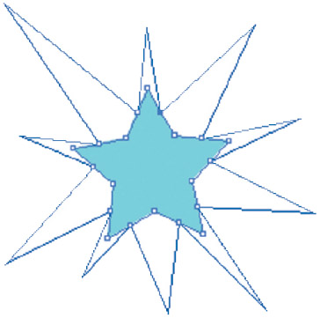
Figure 70 Star selected with Direct Selection tool View PDF

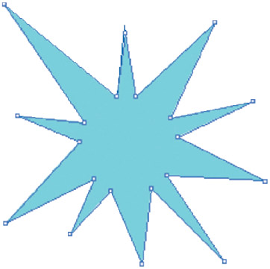
Figure 71 Completed starburst View PDF

Back to TopP. 1_58

Figure 72 Red rectangle sent to the back of the stacking order View PDF

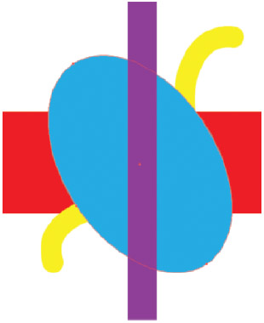
Figure 73 Blue oval moved forward in the stacking order View PDF

Use the Draw Behind Drawing Mode
1. Click the Expand panels button
at the top of the Tools panel if necessary to display the tools in two rows.
When the Tools panel is displayed in two rows, the three drawing modes are visible as icons at the bottom. When the panel is displayed in a single row, you need to click the Drawing Modes icon to display the tools in a submenu.
2. Note the four objects in the bottom-left quadrant of the artboard.
The blue oval is at the back, the purple rectangle is in front of the blue oval, the curvy yellow path is in front of the purple rectangle, and the red rectangle is at the front.
3. Click the Selection tool
, click the red rectangle, click Object on the Menu bar, point to Arrange, then click Send to Back.
As shown in Figure 72, the red rectangle moves to the back of the stacking order.
4. Select the yellow path, click Object on the Menu bar, point to Arrange, then click Send Backward.
The path moves one level back in the stacking order. When discussing the stacking order, it's smart to use the term “level” instead of “layer.” In Illustrator, layers are different than the stacking order.
5. Select the blue oval, click Object on the Menu bar, point to Arrange, then click Bring Forward.
As shown in Figure 73, the blue oval moves one level forward in the stacking order.

Back to TopP. 1_59

6. Select the purple rectangle, then click the Draw Behind button at the bottom of the Tools panel.
There are three available drawing modes: Draw Normal, Draw Behind, and Draw Inside.
7. Click the Ellipse tool on the Tools panel, then draw a circle at the center of the blue oval.
The circle is created behind the purple rectangle, though it still appears to be in front while it is selected. With the Draw Behind drawing mode activated, an object you draw will be positioned one level behind any selected object on the artboard. If no object is selected, the new object will be positioned at the back of the stacking order.
8. Click the Eyedropper tool, click the red rectangle, then compare your artboard to Figure 74.
The Eyedropper tool samples the fill and stroke color from the red rectangle and applies it to the selected object.
9. Click the Draw Normal button, then save your work.
You arranged objects on the artboard, used the Draw Behind feature, then changed the color of the circle you created.

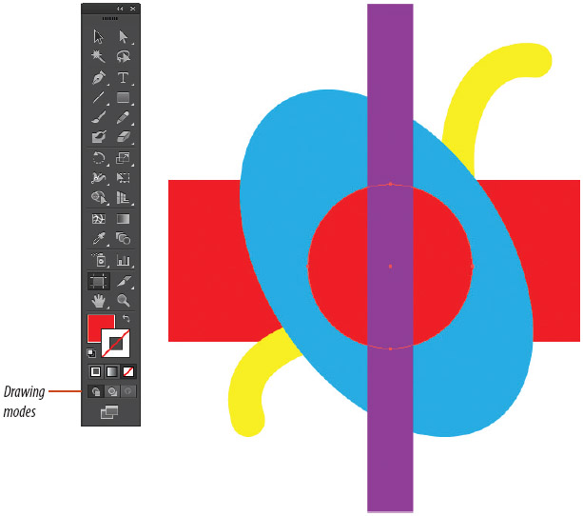
Figure 74 The new red circle behind the purple rectangle View PDF

Back to TopP. 1_60

Figure 75 Completed linked squares View PDF

Create a Simple Special Effect Utilizing a Direct Selection
1. Click the Selection tool
, overlap the large orange and blue squares so that they resemble the small orange and blue squares, then deselect.
2. Click the Direct Selection tool
, then select the top path segment of the orange square.
It will look like the whole square is selected, but you will see white anchor points in the four corners.
3. Copy the path.
4. Select the intersecting path segment on the blue square.
5. Paste in front, then save your work. Your work should resemble Figure 75.
6. Close the document.

