Chapter 1- Lesson 5

What You'll Do

View PDF

In this lesson you will use the Swatches panel to add a fill color to an object and apply a stroke as a border. Then you will use the Stroke panel to change the size of the default stroke.

Activating the Fill or Stroke
The Fill and Stroke buttons are on the Tools panel. To apply a fill or stroke color to an object, you must first activate the appropriate button. You activate either button by clicking it, which moves it in front of the other. When the Fill button is in front of the Stroke button, the fill is activated, as shown in Figure 50. The Stroke button is activated when it is in front of the Fill button.
As you work, you will often switch back and forth, activating the fill and the stroke. Rather than using your mouse to activate the fill or the stroke each time, simply press [X] to switch between the two modes.

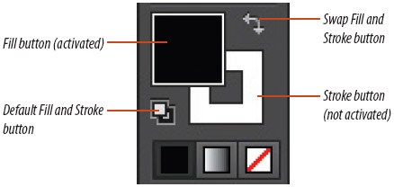
Figure 50 Fill and Stroke buttons View PDF

Back to TopP. 1_40

Applying Color with the Swatches Panel
The Swatches panel, as shown in Figure 51, is central to color management in the application and a simple resource for applying fills and strokes to objects.
The Swatches panel has 47 preset colors, along with gradients, patterns, and shades of gray. The swatch with the red line through it is called [None] and is used as a fill for a “hollow” object. Any object without a stroke will always have [None] as its stroke color.
When an object is selected, clicking a swatch on the panel will apply that color as a fill or a stroke, depending on which of the two is activated on the Tools panel. You can also drag and drop swatches onto unselected objects. Dragging a swatch to an unselected object will change the color of its fill or stroke, depending upon which of the two is activated.

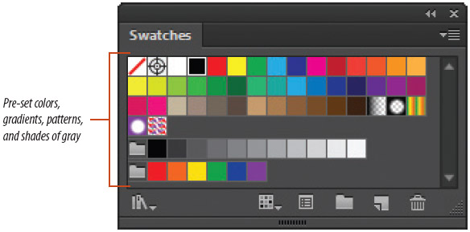
Figure 51 Swatches panel View PDF

Back to TopP. 1_41

Apply Fill and Stroke Colors
1. Verify that the new square is still selected.
2. Click the Swatches icon
in the stack of collapsed panels to open the Swatches panel. Your Swatches panel may already be available.
3. Click any blue swatch on the Swatches panel to fill the square.
Note that the Fill button on the Tools panel is now also blue.

MORE INFO COLLAPSE ALL

Tip
When you position your pointer over a color swatch on the Swatches panel, a tool tip appears that shows the name of that swatch.
4. Click the Selection tool
, then click anywhere on the artboard to deselect the blue square.
5. Drag and drop a yellow swatch onto the blue square.
The fill color changes to yellow because the Fill button is activated on the Tools panel. Your colors may vary from the colors shown in the figures.
6. Press [X] to activate the Stroke button on the Tools panel.
7. Drag and drop the red swatch on the Swatches panel onto the yellow square.
As shown in Figure 52, a red stroke is added to the square because the Stroke button is activated on the Tools panel.

Figure 52 Red stroke is added to the yellow square View PDF

Back to TopP. 1_42

Figure 53 Yellow square without a stroke View PDF
8. Click the Stroke icon
in the stack of collapsed panels to display the Stroke panel.
9. Select the square on the artboard, click the Weight list arrow on the Stroke panel, then click 20 pt.

MORE INFO COLLAPSE ALL

Tip
Illustrator positions a stroke equally inside and outside an object. Thus, a 20 pt stroke is rendered with 10 pts inside the object and 10 pts outside.
10. Note the Align Stroke section on the Stroke panel.
11. Click the Align Stroke to Inside button. The entire stroke moves to the inside of the square.
12. Click the Align Stroke to Outside button. The entire stroke moves to the outside of the square.
13. Click the Align Stroke to Center button. The stroke is returned to the default position, equally inside and outside the object.
14. Click [None]
on the Swatches panel to remove the stroke from the square.
Your screen should resemble Figure 53.
15. Save your work.
You filled the square with blue by clicking a blue swatch on the Swatches panel. You then changed the fill and stroke colors to yellow and red by dragging and dropping swatches onto the square. You used the Stroke panel to increase the weight and change the alignment of the stroke, then removed it by choosing [None] from the Swatches panel.

