Chapter 1- Lesson 1

Explore the Tools Panel
1. Launch Adobe Illustrator CS6.
2. Click File on the Menu bar, click Open, navigate to the drive and folder where your Chapter 1 Data Files are stored, click AI 1-1.ai, then click Open.
3. Click Window on the Menu bar, point to Workspace, then click [Essentials].
Compare your window to Figure 13.

MORE INFO COLLAPSE ALL

Tip
If you are already working in the Essentials workspace, click Reset Essentials on the Workspace menu.
4. Click the double-arrows on the Tools panel, then click it again to switch between the two setups for the Tools panel.
All of the figures in this book that show the Tools panel will display the panel in two rows.
5. Point to the Type tool
, then press and hold the mouse button to see the Type on a Path tool.
6. View the hidden tools behind the other tools with small black triangles.
Your visible tools may differ from the figure.
7. Click Edit (Win) or Illustrator (Mac) on the Menu bar, point to Preferences, click General, verify that Show Tool Tips is checked, then click OK.
8. Position your mouse pointer over the Selection tool
, until its tool tip appears.
9. Press the following keys and note which tools are selected with each key: [a], [p], [v], [t], [i], [h], [z].

Back to TopP. 1_11

10. Press [Tab] to temporarily hide all open panels, then press [Tab] again.
The panels reappear.
You explored different views of the Tools panel, revealed hidden tools, used shortcut keys to access tools quickly, hid the panels, then displayed them again.

Work with Panels
1. Click Swatches in the stack of collapsed panels to the right of the pasteboard to open the Swatches panel.
The panel opens, but does not detach from the stack of collapsed panels. The Swatches panel is grouped with the Symbols and Brushes panels in the Essentials workspace.
2. Click the Collapse panels button
at the top of the panel to minimize the panel, then click Swatches to open the panel again.
3. Drag the Swatches panel name tab to the left so it is ungrouped from the stack.
4. Click Color in the stack of collapsed panels to the right of the pasteboard to open the Color panel.

MORE INFO COLLAPSE ALL

Tip
If you do not see the CMYK sliders in the Color panel, as shown in Figure 14, click the Color Panel Options button, then click Show Options.
5. Drag the Color panel name tab to the left so it is ungrouped from the stack.
6. Drag the Color panel name tab to the blank space next to the Swatches panel name tab, then release the mouse.

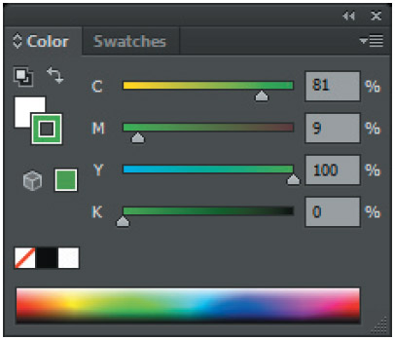
Figure 14 Grouped panels View PDF

MORE INFO COLLAPSE ALL

Using the Document Info Panel
The Document Info panel, listed on the Window menu, contains useful information about the document and about objects in the document. Along with general file information such as filename, ruler units and color space, the panel lists specific information like the number and names of graphic styles, custom colors, patterns, gradients, fonts, and placed art. To view information about a selected object, choose Selection Only from the panel menu. Leaving this option deselected lists information about the entire document. To view artboard dimensions, click the Artboard tool, choose Document from the panel menu, and then click to select the artboard you want to view.

Back to TopP. 1_12

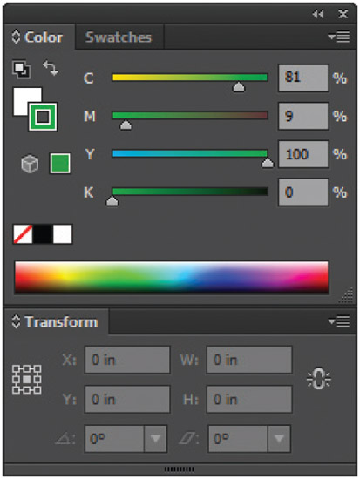
Figure 15 Docked panels View PDF
The Color panel is grouped with the Swatches panel, as shown in Figure 14.
7. Click Window on the Menu bar, then click Transform.
The Transform panel appears expanded on the document.
8. Drag the Transform panel name tab to the bottom edge of the Swatches and Color panels group, then, when a blue horizontal line appears, release the mouse.
The Transform panel is docked, as shown in Figure 15.
9. Click and drag the dark gray bar at the top of the panel group, found above the Swatches and Color panel name tabs.
The Transform panel moves with the Swatches and Color panels because it is docked.
10. Click the Transform panel name tab, then drag it away from the other two panels.
The Transform panel is undocked.
11. Click Window on the Menu bar, point to Workspace, then click Reset Essentials.
You explored methods for grouping and ungrouping panels, then you docked and undocked a panel.

Back to TopP. 1_13

