Chapter 1-Lesson 7: Transform Objects Pages 1_48 to 1_53

Transforming Objects
Repeating Transformations
Use the Scale and Rotate Tools
Use the Transform Again Command
Create a Star and a Triangle, and Use the Reflect Tool

MORE INFO COLLAPSE ALL

What You'll Do

View PDF

In this lesson, you will scale, rotate, and reflect objects, using the basic transform tools. You will also create a star and a triangle.

Transforming Objects
The Scale, Rotate, and Reflect tools are the fundamental transform tools. As their names make clear, the Scale and Rotate tools resize and rotate objects, respectively. When you use the tool's dialog box, the objects are transformed from their center points. This can be a useful choice because the object's position essentially doesn't change on the artboard or in relation to other objects.
Use the Reflect tool to “flip” an object over an imaginary axis. The best way to understand the Reflect tool is to imagine positioning a mirror perpendicular to a sheet of paper with a word written on it. The angle at which you position the mirror in relation to the word is the reflection axis. The reflection of the word in the mirror is the end result of what the Reflect tool does. For example, text reflected across a horizontal axis would appear upside down and inverted. Text reflected across a vertical axis would appear to be inverted and running backwards, as shown in Figure 59.

Back to TopP. 1_48

You can transform an object using the desired tool or its dialog box. Each transform tool has a dialog box where you can enter precise numbers to execute the transformation on a selected object. You can access a tool's dialog box by double-clicking the tool. Click the Copy button in the dialog box to create a transformed copy of the selected object. Figure 60 shows the Scale dialog box.

Repeating Transformations
One of the most powerful commands relating to the transform tools is Transform Again, found on the Object menu. Unfortunately, it is a command often overlooked by new users. Whenever you transform an object, selecting Transform Again repeats the transformation. For example, if you scale a circle 50%, the Transform Again command will scale the circle 50% again.
The power of the command comes in combination with copying transformations. For example, if you rotate a square 10° and copy it at the same time, the Transform Again command will create a second square rotated another 10° from the first copy. Applying Transform Again repeatedly is handy for creating complex geometric shapes from basic objects.

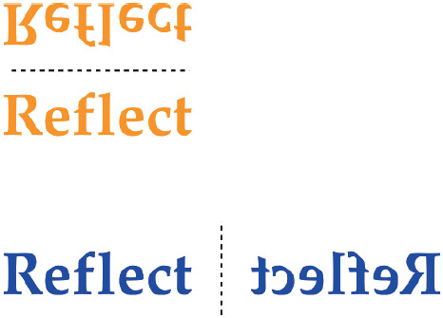
Figure 59 Reflected text View PDF

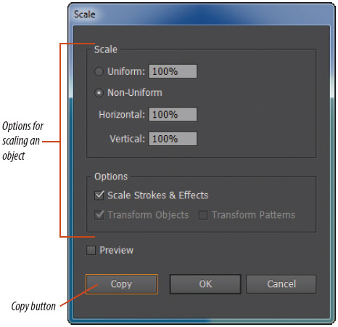
Figure 60 Scale dialog box View PDF

Back to TopP. 1_49

Use the Scale and Rotate Tools
1. Select the green square, double-click the Scale tool
, type 50 in the Scale text box, then click OK.
2. Click Edit on the Menu bar, then click Undo Scale.

MORE INFO COLLAPSE ALL

Tip
You can also undo your last step by pressing [Ctrl][Z] (Win) or
[Z] (Mac).
3. Double-click the Scale tool
again, type 50 in the Scale text box, then click Copy.
The transformation is executed from the center point; the center points of the original and the copy are aligned.
4. Fill the new square created in Step 3 with blue.
5. Double-click the Rotate tool
, type 45 in the Angle text box, click OK, then click the Selection tool
.
6. Apply a 22 pt yellow stroke to the rotated square, deselect, then compare your screen to Figure 61.
You used the Scale tool to create a 50% copy of the square, then filled the copy with blue. You rotated the copy 45°. You then applied a 22 pt yellow stroke.

Figure 61 Scaling and rotating a square View PDF

Back to TopP. 1_50

Figure 62 Using the Transform Again command View PDF

Use the Transform Again Command
1. Click the Ellipse tool
on the Tools panel.

MORE INFO COLLAPSE ALL

Tip
To access the Ellipse tool, press and hold the Rectangle tool until a toolbar of shape tools appears, then click the Ellipse tool.
2. Click the artboard, type 3 in the Width text box and .5 in the Height text box, then click OK.
3. Change the fill color to [None], the stroke color to blue, and the stroke weight to 3 pt.
4. Click the Selection tool
, click the center point of the ellipse, then drag it to the center point of the yellow square.

MORE INFO COLLAPSE ALL

Tip
The center smart guide appears when the two centers meet.
5. Double-click the Rotate tool
, type 45 in the Angle text box, then click Copy.
6. Click Object on the Menu bar, point to Transform, then click Transform Again.

MORE INFO COLLAPSE ALL

Tip
You can also access the Transform Again command by pressing [Ctrl] [D] (Win) or
[D] (Mac).
7. Repeat Step 6 to create a fourth ellipse using the Transform Again command.
Your screen should resemble Figure 62.
8. Select the four ellipses, click Object on the Menu bar, then click Group.
You created an ellipse, filled and stroked it, and aligned it with the yellow square. You then created a copy rotated at 45°. With the second copy still selected, you used the Transform Again command twice, creating two more rotated copies. You then grouped the four ellipses.

Back to TopP. 1_51

Create a Star and a Triangle, and Use the Reflect Tool
1. Select the Star tool
, then click anywhere on the artboard.
The Star tool is hidden beneath the current shape tool.
2. Type 1 in the Radius 1 text box, type 5 in the Radius 2 text box, type 5 in the Points text box, as shown in Figure 63, then click OK.
A star has two radii; the first is from the center to the inner point, and the second is from the center to the outer point. The radius is a measurement from the center point of the star to either point.
3. Double-click the Scale tool
, type 25 in the Scale text box, then click OK.
When you create a star using the Star dialog box, the star is drawn upside down.
4. Fill the star with white, then apply a 5 pt blue stroke to it.
5. Click the Selection tool
, then move the star so that it is completely within the red square.
6. Double-click the Reflect tool
, click the Horizontal option button, as shown in Figure 64, then click OK.
The star “flips” over an imaginary horizontal axis.

MORE INFO COLLAPSE ALL

Tip
The Reflect tool is hidden beneath the Rotate tool.
7. Use the Selection tool
or the arrow keys to position the star roughly in the center of the red square.
Your work should resemble Figure 65.

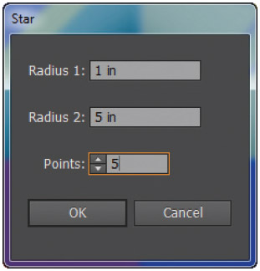
Figure 63 Star dialog box View PDF

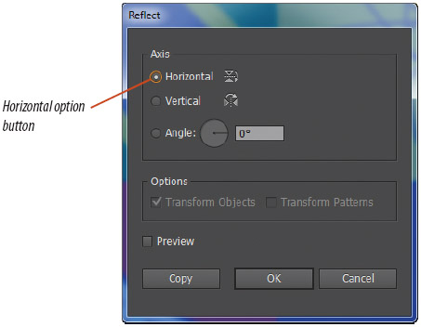
Figure 64 Reflect dialog box View PDF

Figure 65 Reflecting the star horizontally View PDF

Back to TopP. 1_52

Figure 66 The finished project View PDF

MORE INFO COLLAPSE ALL

Tip
Arrow keys move a selected item in 1 pt increments, known as the Keyboard Increment. You can change this amount by clicking Edit (Win) or Illustrator (Mac) on the Menu bar, pointing to Preferences, clicking General, then typing a new value in the Keyboard Increment text box.
8. Click the Polygon tool
on the Tools panel.
The Polygon tool is hidden beneath the current shape tool on the Tools panel.
9. Click anywhere on the blue square.
10. Type 1.5 in the Radius text box, type 3 in the Sides text box, then click OK.
11. Fill the triangle with red.
12. Change the stroke color to yellow and the stroke weight to 22 pt.
13. Position the triangle so that it is centered within the blue square.
Your completed project should resemble Figure 66.
14. Save your work, then close Basic Shapes.
You used the shape tools to create a star and a triangle, then used the Reflect tool to “flip” the star over an imaginary horizontal axis.

