Chapter 1- Lesson 3

Set Essential Preferences
1. Click Edit (Win) or Illustrator (Mac) on the Menu bar, point to Preferences, then click General.
For the remainder of this chapter and this book, use this combination of commands to find your preferences dialog boxes.
2. Set your General preferences to match Figure 31. The keyboard increment determines the distance a selected object moves when you click an arrow key on your keypad. The measurement entered, .0139″ is equivalent to 1 pt. The Show Tool Tips option will reveal a tool's name when you position your cursor over it. The Scale Strokes & Effects option means that, for example, if you apply a 200% scale to an object that has a 1 pt stroke, the result will be an object with a 2 pt stroke.

MORE INFO COLLAPSE ALL

Tip
If you press and hold [Shift] while pressing the arrow keys, a selected object moves a distance that is 10X the keyboard increment.
3. Click Units in the left side of the Preferences dialog box, then make sure your settings match those shown in Figure 32.
All the general artboard measurements in this book are based on inches. In almost all cases, you'll want to work with strokes and type in point measurements.
4. Click Guides & Grid in the left side of the Preferences dialog box, then make sure your settings match those shown in Figure 33.

Back to TopP. 1_27

Note that you have options for showing your guides as dots.
5. Click Smart Guides in the left side of the Preferences dialog box, then enter the settings shown in Figure 34.
It's a good idea for your smart guides to be a distinctly different color than your ruler guides and artboard grid.
6. Click User Interface in the left side of the Preferences panel, then make sure your settings match those shown in Figure 35.
The brightness slider defines how light or dark the Illustriator interface is.
7. Click OK.
You specified various essential preferences in different Preferences dialog boxes.

Resize Objects
1. Open A1-2.ai, then save it as Objects.
2. Click View on the Menu bar, then verify that the Bounding Box command says Show Bounding Box.
3. Click the Selection Tool
, then click the pink square to select it.
As shown in Figure 36, the paths and the anchor points that draw the square are revealed, as is the object's center point.
4. Click View on the Menu bar, then click Show Bounding Box.
Eight “hollow” handles appear around the rectangle, as shown in Figure 37.

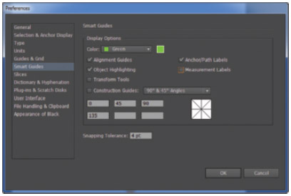
Figure 34 Setting Smart Guides preferences View PDF

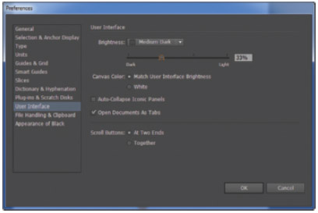
Figure 35 Setting User Interface preferences View PDF

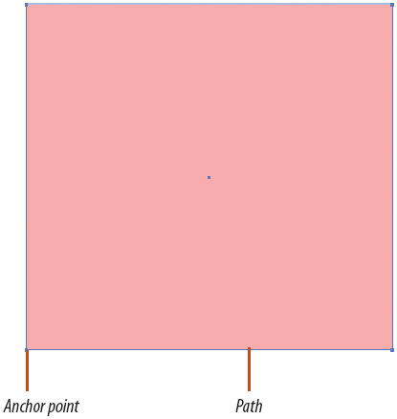
Figure 36 Viewing paths and points on a selected object View PDF

Figure 37 Viewing the bounding box View PDF

Back to TopP. 1_28

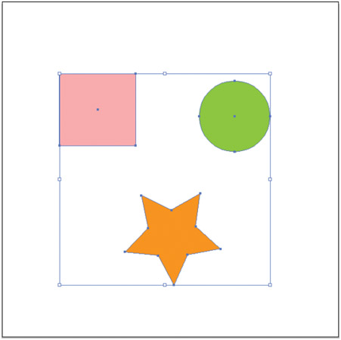
Figure 38 All objects selected on the artboard View PDF
5. Click and drag various handles and note how the object is resized.
6. When you are done experimenting, undo all of the moves you made.
The Undo command is at the top of the Edit menu.
7. Press and hold down [Shift], while dragging the top-left corner handle to the left edge of the document.
The object is resized proportionately.
8. Undo the move.
9. Click the green circle to select it.
10. Press and hold down [Alt] (Win) or [option] (Mac), then start dragging any corner handle.
As you drag, the object is resized from its center.
11. While still holding down [Alt] (Win)or [option] (Mac) and dragging, press and hold [Shift].
The object is resized in proportion from its center.
12. Scale the circle to any size.
13. Undo the move.
14. Click Select on the Menu bar, then click All.
All of the objects on the artboard are selected. The bounding box appears around all three objects, as shown in Figure 38.
Make it a point to remember the quick key for Select All: [Ctrl-A] (Win) or
[A] (Mac).

Back to TopP. 1_29

15. Using the skills you learned in this lesson, reduce the size of the objects in proportion so that they are very small on the artboard, then click the artboard to deselect the objects. Your artboard should resemble Figure 39.
16. Click File on the Menu bar, click Revert, then click Revert when you are prompted to confirm. Reverting a file returns it to its status when you last saved it. You can think of it as a “super undo.”
You explored various options for resizing objects, then you reverted the file.

Copy and Duplicate Objects
1. Click View on the Menu bar, then click Hide Bounding Box.
2. Select the star, then copy it, using the [Ctrl] [C] (Win) or
[C] (Mac) shortcut keys.
3. Click Edit on the Menu bar, then click Paste.
A copy of the star is placed at the center of the artboard.
4. Undo the paste.
5. Click Edit on the Menu bar, then click Paste in Front.
The copy is pasted directly in front of the original star.

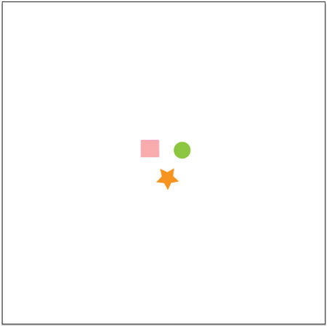
Figure 39 Resized object and contents View PDF

Back to TopP. 1_30

Figure 40 Two stars pasted in front and in back of the original View PDF
6. Press [I] on your keypad to switch to the Eyedropper tool, then click the pink square. The star takes on the same fill and stroke colors as the square.
7. Press
on your keypad ten times.
8. Deslect all, click Edit on the Menu bar, then click Paste in Back.
A copy of the star is pasted directly behind the original orange star that was copied.
9. Click the Eyedropper tool on the green circle.
10. Press and hold [Shift], then press
on your keypad one time.
11. Press and hold [Ctrl] (Win) or
(Mac) so that your cursor switches from temporarily from the Eyedropper tool to the Selection tool, then click the artboard with the Selection tool to deselect all. Pressing [Ctrl] or
is a quick way to switch temporarily to the Selection tool.
12. Compare your artboard to Figure 40.
13. Click the Selection tool
, then select the green circle.

Back to TopP. 1_31

14. Press and hold down [Alt] (Win) or [Option] (Mac), then drag a copy of the circle to the center of the square.
Your screen should resemble Figure 41.

MORE INFO COLLAPSE ALL

Tip
This method for creating a copy is referred to as “drag-and-drop a copy.”
15. Save your work, then close the file.
You copied and pasted an object, noting that it pasted by default in the center of the artboard. You used the Paste in Front and Paste in Back command along with arrow keys to make two off set copies of the star. You duplicated the circle with the drag-and-drop technique.

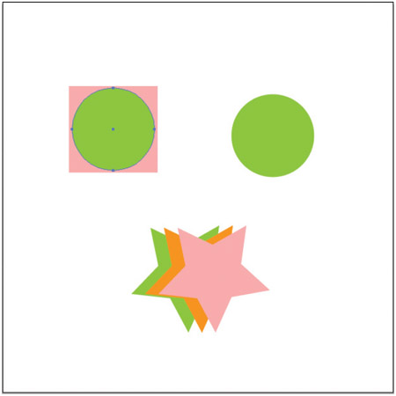
Figure 41 Dragging and dropping a copy of the circle View PDF

Back to TopP. 1_32

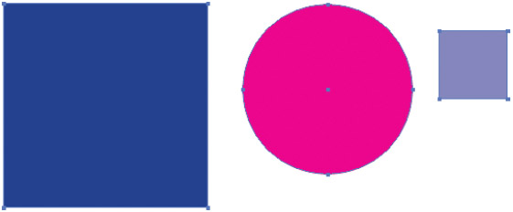
Figure 42 Three grouped objects View PDF

Hide, Lock, and Group Objects
1. Open AI 1-3.ai, then save it as Groups.
2. Click Object on the Menu bar, then click Show All.
This document was originally saved with hidden objects. Three objects appear. They are all selected.
3. Click Object on the Menu bar, then click Group.
4. Click the Selection tool
, click anywhere on the pasteboard to deselect all, then click the Pink circle.
As shown in Figure 42, all three objects are selected because they are grouped.
5. Click the pasteboard to deselect all, click the Direct Selection tool
, then click the pink circle.
Only the circle is selected, because the Direct Selection tool selects individual objects within a group.
6. Select all, click Object on the Menu bar, then click Ungroup.
7. Click the Selection tool
, select the small square, click Object on the Menu bar, point to Lock, then click Selection.
The object's handles disappear and it can no longer be selected.
8. Click Object on the Menu bar, then click Unlock All.
The small square is unlocked.

Back to TopP. 1_33

9. Select all, click Object on the Menu bar, point to Hide, then click Selection.
All selected objects disappear.
10. Click the Object menu, then click Show All.
The three objects reappear in the same location that they were in when they were hidden.

MORE INFO COLLAPSE ALL

Tip
Memorize the shortcut keys for Hide/Show, Group/Ungroup, and Lock/Unlock. They are easy to remember and extremely useful. You will be using these commands over and over again when you work in Illustrator.
11. Hide the pink circle and the small square.
12. Save the file.
You revealed hidden objects, grouped them, then used the Direct Selection tool to select individual objects within the group. You ungrouped, locked, unlocked, and hid objects.

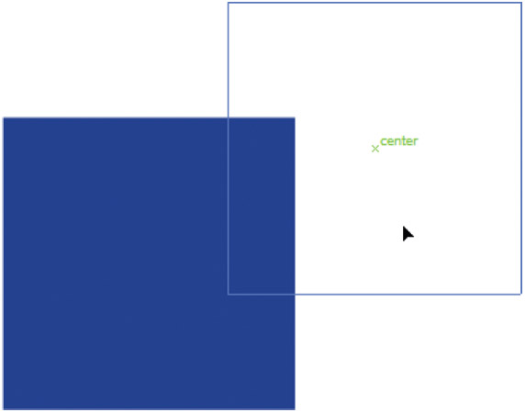
Figure 43 Smart guide aligning square with center of artboard View PDF

Back to TopP. 1_34

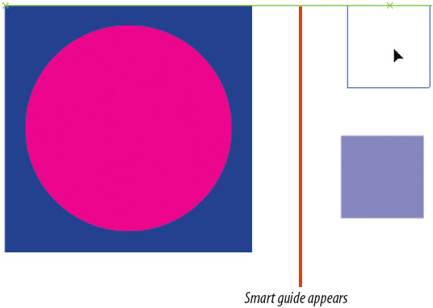
Figure 44 Aligning the tops of two squares View PDF

Figure 45 Aligning bottoms of two squares View PDF

Work with Smart Guides
1. Click View on the Menu bar, then click Smart Guides if it is not already checked.
2. Click the large blue square, then try to center it visually on the page.
3. Release your mouse when the word CENTER appears, as shown in Figure 43.
Smart guides use the word CENTER to identify when the center point of an object is in line with the center point of the artboard.
4. Show the hidden objects, then hide the small square.
5. Using the same methodology, align the center of the pink circle with the center of the large blue square.
6. Show the hidden small square.
7. Use smart guides to align the top of the small square with the top of the large square, as shown in Figure 44.
8. Position the small square as shown in Figure 45.
9. Save, then close the file.
You aligned an object at the center of the document and created precise relationships among three objects using smart guides.

