Chapter 1-Lesson 4

Use the Rectangle Tool
1. Click File on the Menu bar, click New, create a new document that is 8" wide by 8" in height, name the fileBasic Shapes, then click OK.
2. Click File on the Menu bar, click Save As, navigate to the drive and folder where your Data Files are stored, click Save, then click OK to close the Illustrator Options dialog box.
3. Click the Default Fill and Stroke button
on the Tools panel.
4. Click the Swap Fill and Stroke button
on the Tools panel to reverse the default colors.
Your fill color should now be black and your stroke color white. The fill color is the inside color of an object. The stroke color is the color of the object's border or frame.
5. Click the Rectangle tool
on the Tools panel.
6. Click and drag the Rectangle tool pointer on the artboard, then release the mouse pointer to make a rectangle of any size.
7. Press and hold [Shift] while you create a second rectangle.
Pressing and holding [Shift] while you create a rectangle constrains the shape to a perfect square, as shown in Figure 48.
8. Create a third rectangle drawn from its center point by pressing and holding [Alt] (Win) or [option] (Mac) as you drag the Rectangle tool pointer.

MORE INFO COLLAPSE ALL

Tip
Use [Shift] in combination with [Alt] (Win) or [option] (Mac) to draw a perfect shape from its center.
You created a freeform rectangle, then you created a perfect square. Finally you drew a square from its center point.

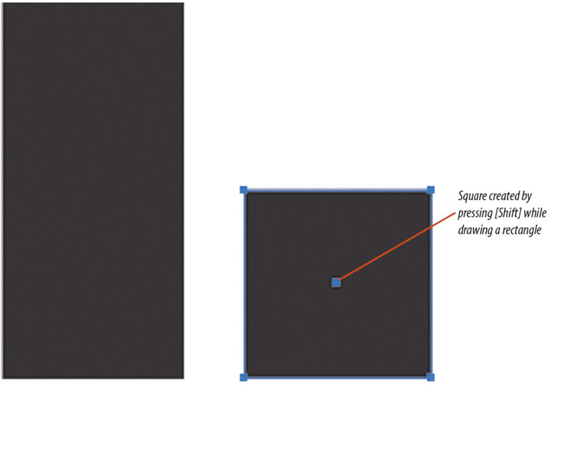
Figure 48 Creating a rectangle and a square View PDF

Back to TopP. 1_38

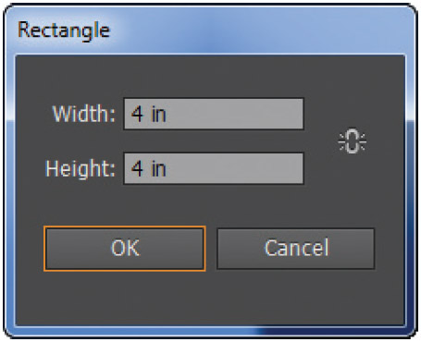
Figure 49 Rectangle dialog box View PDF

Use the Rectangle Dialog Box
1. Click Select on the Menu bar, then click All to select all of the objects.
2. Click Edit on the Menu bar, then click Cut to remove the objects from the artboard.
3. Click anywhere on the artboard.
When a shape tool is selected, clicking once on the artboard opens a dialog box, which allows you to enter precise information for creating the object. In this case, it opens the Rectangle dialog box.
4. Type 4 in the Width text box, type 4 in the Height text box, as shown in Figure 49, then click OK.
5. Save your work.
You clicked the artboard with the Rectangle tool, which opened the Rectangle dialog box. You entered a specific width and height to create a perfect 4" square.

