Chapter 1 Lesson 6: Select, Move, and Align Objects Pages 1_44 to 1_47

Selecting and Moving Objects
Making a Marquee Selection
Move and Position Objects with Precision
Duplicate Objects Using Drag and Drop

MORE INFO COLLAPSE ALL

What You'll Do

View PDF

In this lesson, you will use the Selection tool in combination with smart guides to move, copy, and align four squares.

Selecting and Moving Objects
When it comes to accuracy, consider that Illustrator can move objects incrementally by fractions of a point—which itself is a tiny fraction of an inch! That level of precision is key when moving and positioning objects.
Before you can move or modify an Illustrator object, you must identify it by selecting it with a selection tool, menu item, or command key. When working with simple illustrations that contain few objects, selecting is usually simple, but it can become very tricky in complex illustrations, especially those containing a large number of small objects positioned closely together.

Back to TopP. 1_44

Two very basic ways to move objects are by clicking and dragging or by using the arrow keys, which by default move a selected item in 1 pt increments. Pressing [Shift] when dragging an object constrains the movement to horizontal, vertical, and 45° diagonals. Pressing [Alt] (Win) or [option] (Mac) while dragging an object creates a copy of the object.

Making a Marquee Selection
By now, you're familiar with using the Selection tool to select objects. You can also use the Selection tool to create a marquee selection, which is a dotted rectangle that disappears as soon as you release the mouse button. Any object that the marquee touches before you release the mouse button will be selected. See Figure 54.
Marquee selections are useful for both quick selections and precise selections. Make sure you practice and make them part of your skill set.

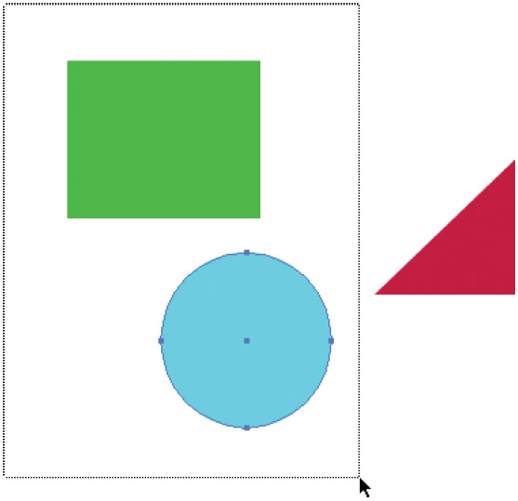
Figure 54 Making a marquee selection View PDF

Back to TopP. 1_45

Move and Position Objects with Precision
1. Click View on the Menu bar, then click Fit Artboard in Window.
2. Click View on the Menu bar, then verify that both Smart Guides and Snap to Point are selected.

MORE INFO COLLAPSE ALL

Tip
There will be a check next to each if they are selected. If they are not selected, click each option to select it.
Snap to Point automatically aligns anchor points when they get close together. When dragging an object, you'll see it “snap” to align itself with a nearby object or guide.
3. Click the Selection tool
on the Tools panel, then click the yellow square.
4. Identify the anchor points, paths, and center point, as shown in Figure 55.
5. Move the Selection tool pointer over the anchor points, over the paths that connect the points, and over the center point.
6. Position the pointer over the top-left anchor point, click and drag so that the anchor point aligns with the top-left corner of the artboard, as shown in Figure 56, then release the mouse.
The smart guide changes from “anchor” to “intersect” when the two corners are aligned.
You used the Selection tool in combination with smart guides to position an object exactly at the top-left corner of the artboard.

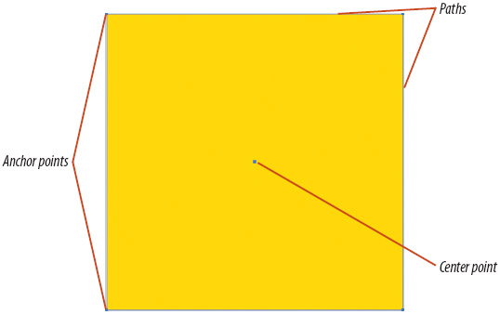
Figure 55 Anchor points, paths, and center point View PDF

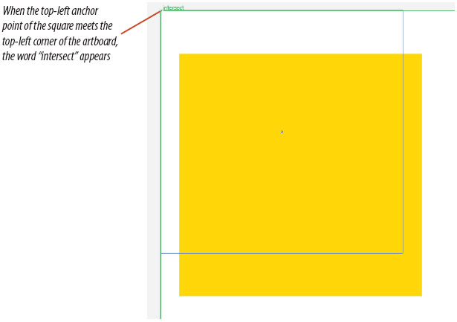
Figure 56 Intersecting two points View PDF

Back to TopP. 1_46

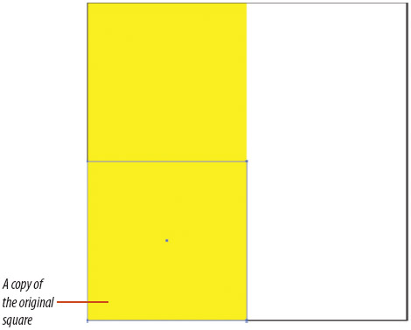
Figure 57 Duplicating the square View PDF

Figure 58 Four squares created using drag and drop View PDF

Duplicate Objects Using Drag and Drop
1. Click the top-left anchor point without releasing the mouse button, press and hold [Shift] [Alt] (Win) or [Shift] [option] (Mac) while dragging straight down until the top-left anchor point touches the bottom-left anchor point (the “intersect” smart guide will appear), then release the mouse.
When moving an object, pressing and holding [Shift] constrains the movement vertically, horizontally, or on 45° diagonals. Pressing [Alt] (Win) or [option] (Mac) while dragging an object creates a copy of the object, as shown in Figure 57.

MORE INFO COLLAPSE ALL

Tip
When you press [Alt] (Win) or [option] (Mac) while dragging an object, the pointer becomes a double-arrow pointer. When two anchor points are directly on top of each other, the Selection tool pointer turns from black to white.
2. With the bottom square still selected, press and hold [Shift], then click the top square to select both items.
3. Click the top-left anchor point of the top square without releasing the mouse button, press and hold[Shift] [Alt] (Win) or [Shift] [option] (Mac), while dragging to the right until the top-left anchor point touches the top-right anchor point, then release the mouse.
4. Change the fill color of each square to match the colors shown in Figure 58.
5. Save your work.
You moved and duplicated the yellow square using [Shift] to constrain the movement and [Alt] (Win) or [option] (Mac) to duplicate or “drag and drop” copies of the square.

